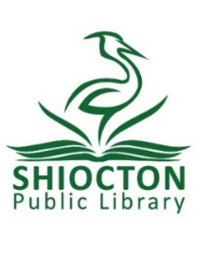
Notice of Meeting
Thursday, March 14 2024 at 2:00pm
Shiocton Public Library Board
Outagamie County

Notice is hereby given that a meeting of the Shiocton Public Library Board of Trustees will be held on March 14, 2024 at 2:00pm
At the Shiocton Public Library Community Room: W7740 Pine St, Shiocton WI 54170.

This is an open meeting and may be attended by the public.
An agenda for the meeting is as follows:
- Call to Order
- Pledge of Allegiance to the Flag of the United States of America
- Roll Call
- Approval of Meeting Minutes from February 21, 2023
- Approval of February Financial Reports and Bills
- Public Comment
- Director’s Report
- Discuss planning for Easter Egg Hunt 2024
- Library Board Comments
- Next Meeting Date
- Adjournment

The Shiocton Public Library Community Room is accessible to the physically disadvantaged. If special accommodations are needed, please contact the Shiocton Public Library at (920)-986-3933.

Posted and dated March 11th, 2024 by Michaela Woodward- Shiocton Public Library Director

